Who Cares About Crackdowns? Exploring the Role of Trust in Individual Philanthropy
May 13, 2021
The phenomenon of closing civic space has adversely impacted INGO funding. We argue that individual private donors can be important in sustaining the operations of INGOs working in repressive contexts. Individual donors do not use the same performance-based metrics as official aid donors. Rather, trust can be an important component of individual donor support for nonprofits working towards difficult goals. How does trust in charitable organizations influence individuals’ preferences to donate, especially when these groups face crackdown? Using a simulated market for philanthropic donations based on data from a nationally representative sample of individuals in the United States who regularly donate to charity, we find that trust in INGOs matters substantially in shaping donor preferences. Donor profiles with high levels of social trust are likely to donate to INGOs with friendly relationships with host governments. This support holds steady if INGOs face criticism or crackdown. In contrast, donor profiles with lower levels of social trust prefer to donate to organizations that do not face criticism or crackdown abroad. The global crackdown on NGOs may thus possibly sour NGOs’ least trusting individual donors. Our findings have practical implications for INGOs raising funds from individuals amid closing civic space.
In 2016, Human Rights Watch claimed that civil society was under more aggressive attack than at any time in recent memory (Roth, 2016). Globally, governments are repressing civil society organizations (CSOs) and non-governmental organizations (NGOs)—a phenomenon known as “closing civic space” (Carothers & Brechenmacher, 2014; CIVICUS, 2017; K. Dupuy et al., 2016; K. E. Dupuy et al., 2015). Legal restrictions, or what we refer to as legal crackdowns, are a core part of these efforts. These crackdowns create barriers to entry, funding, and advocacy for NGOs in an effort to control, obstruct, and repress these organizations. Barriers to funding are especially pervasive and restrict the ability of NGOs to secure financial resources. Restrictive states may prevent the transfer of foreign funds to NGOs based on the origin and purposes of these funds.
Due to these laws, official foreign aid channeled through international NGOs (INGOs) has decreased in repressive countries (Brechenmacher, 2017; Chaudhry & Heiss, 2018; K. Dupuy & Prakash, 2018). However, philanthropy from private donors and foundations is not as adversely affected (McGill, 2018). Many foundations have continued channeling funds to countries with hostile legal environments (Needles et al., 2018). Given the reduction of foreign aid following restricted legal environments abroad, INGOs may need to fundraise more from individual donors.
Individual private donations are an important source of INGO funding. While total private philanthropy in the United States has grown over time, it is notable that private giving to NGOs working on international affairs-focused issues are one of only two categories of organizations that have continued experiencing substantial growth in giving, reaching $22.08 billion in donations in 2018 (Giving USA, 2019). Most of this growth is driven by individuals making small-scale (up to $50) or micro-donations (between $0.25–$10) (Saxton & Wang, 2014). In 2017, 70% of donations to international affairs NGOs came from individuals, rising to 86% in 2018 (Giving USA, 2019). But relying on individual donors means that NGOs must consider their preferences when fundraising. Which individual donor characteristics and attributes are most salient for INGOs interested in maximizing philanthropy at a time when they are facing increasingly hostile environments abroad?
A robust scholarship examines the determinants of individual-level philanthropy to domestic causes. But the dynamics of international giving to NGOs are under-examined in the literature on individual donor preferences. Motivating individuals to donate to international causes is hard as the number of recipients are large and far removed from the donor (Casale & Baumann, 2015, p. 100). Trust is an essential component for INGO sustainability—for many nonprofits, trust often translates into grants and donations (Coombs, 2007). Geography often impedes donors’ direct evaluation of their work and trust is one of the most influential criteria that private donors use when deciding which nonprofits to support (Bekkers, 2003; Prakash & Gugerty, 2010). A lack of trust could be further fueled by legal trouble with the INGO host government—a dynamic that individuals may not wish to enter with their dollars. How does trust in INGOs influence individuals’ preferences to donate, especially when groups face crackdown?
We explore this using a simulated market for philanthropic donations towards INGOs, based on data from a nationally representative sample of individuals in the United States who regularly donate to charity. We adapt methods used in marketing to generate distinct simulated personas that represent typical donor profiles, and we vary these personas along different dimensions of demographic, political, and social attributes. We find that an organization’s target issue area and its relationship with its host government interact strongly with individuals’ characteristics. Personas with high levels of trust in political and charitable institutions and who are actively engaged in charity and volunteerism prefer donating to human rights organizations that have friendly relationships with their host governments. In contrast, personas with low levels of social trust eschew both human rights organizations and any type of NGO with more contentious relationships with host governments. Instead, they prefer donating to NGOs with friendly host-country relationships and working on less contentious issues like emergency response and refugee relief. Personas with higher trust are more comfortable donating to legally besieged organizations. Our findings imply that individual donors with high trust would remain supportive of INGOs when they face criticism and crackdown from foreign governments. On the other hand, government crackdown may further sour INGOs’ least trusting donors.
This study contributes both to scholarship and practice in public policy, nonprofits, and philanthropy in three important ways. It helps us understand how the international community and NGOs might respond to the phenomenon of closing civic space. Most NGOs working internationally have previously relied on government and foundation funding. But in the face of decreasing funds from official donors, our results show that INGOs can rely on individual donors—particularly their most trusting donors—when organizations face a hostile environment abroad. These findings lend support to previous literature arguing that trust matters when individuals donate to organizations acting under great uncertainty or working towards difficult goals (Wiepking, 2010).
Second, knowledge of demographic traits and its impact on funding can help nonprofits craft more effective and targeted marketing strategies (Rajan et al., 2009, p. 414). Our paper shows that in readjusting their fundraising strategies towards individuals, framing, or the process through which actors present information to influence perceptions, is particularly important (Chong & Druckman, 2007). Framing affects individuals’ willingness to donate. However, existing research is unclear about which frames are effective when making appeals to individual donors considering international philanthropy. Since our study looks at multiple organizational and host country factors, our results can help INGOs frame their appeals. Our results show that INGOs may benefit from publicizing crackdown at least towards their most trusting donors.
Finally, while research in public policy examines giving to NGOs, the discipline of international relations tends to see philanthropy as less relevant (Youde, 2019). However, philanthropy can help us understand changes in the dynamics of global governance. Private individuals exercise power and influence in unique ways that differ from other non-state actors. As Youde (2019, p. 44) points out, studying philanthropy changes our conceptions of individuals as being passive recipients to active entities that are not merely objects of governance, and can thus shed light on the changing logic of global governance.
Below, we first examine the state of the existing literature on the key drivers of individual giving. We then describe our survey experiment and simulation methods and explore the results. We conclude by discussing the implications of our findings for INGOs facing constrained space for civil society.

Closing civic space and its impact on INGOs
Foreign aid to NGOs has steadily increased over time. Many government and foundation donors perceive NGOs as nimbler and less bureaucratic than governments. In countries with weak institutions and poor governance, where direct aid transfers to governments raise issues of misuse and bureaucratic inefficiency, donors specifically seek out NGOs for projects (Dietrich, 2013). However, NGO-state relationships have also evolved—in the 1950s and 60s, international assistance channeled through NGOs aimed at producing socioeconomic change rather than political progress. But in the aftermath of the dissolution of the Soviet Union, many NGOs had the explicit goal of promoting democracy and bringing down authoritarian governments. Subsequently, many states saw NGOs as a threat and sought to repress them.
More than 100 countries have proposed or enacted 244 measures restricting, repressing, or shutting down civil society since 2013 (International Center for Not-For-Profit Law, 2021). This has had a threefold impact on INGOs. It has led to a reduction in resources and grants available to INGOs. Restrictive NGO laws have affected INGO programming by preventing organizations from working in certain (contentious) issue areas. To deal with this, some groups have adapted by changing the nature of their programming to appear less threatening to the repressive countries. In the worst-case scenario, it has led to a loss in INGOs’ access to target countries. We focus exclusively on the first dilemma—the reduction in INGO funding and possible responses to it.

Changes in INGO funding
INGOs receive funds from a variety of public and private sources. Public funds—or traditional donor aid—channel money from official aid agencies through a variety of bilateral and multilateral institutions. Private sources include foundations, private corporations, and individuals. While INGOs have not been passive in responding to the crackdown on civil society, they face increasing obstacles in acquiring funding. Closing civic space has resulted in net losses of income to INGOs, particularly in official bilateral and multilateral aid (K. Dupuy & Prakash, 2018).
Legal crackdown has also affected how and where funds are allocated. Following the passage of anti-NGO laws, official donors move funds away from contentious causes such as human rights, media, corruption, advocacy, among others, towards tamer and more regime-compatible causes such as health and education (Chaudhry & Heiss, 2018). The latter trend has also been exacerbated by a preference among donors working in the official aid and democracy promotion establishment to gradually increase funding directed towards tame causes, at the expense of more contentious causes. This is because many tame causes can have easily quantifiable, measurable outputs, which makes it easier to show a program’s effectiveness over time (Bush, 2015).
We argue that individual private donors can help fill in an important gap. Individual donors do not use the same performance-based metrics as official donors (Desai & Kharas, 2018). Rather, individual donors often use heuristics to simplify their decision-making, making cursory judgments about an organization’s issue area, mission, vision, and values and seek out supplementary information from friends, family, and acquaintances (Chaudhry & Heiss, 2021; Szper & Prakash, 2011; Tremblay-Boire & Prakash, 2017). Due to these differences, individual donors can help address some of the challenges arising from reduced public funding available to INGOs. To be clear, we are not arguing that individual giving would be a perfect substitute for NGOs’ net loss of income—rather, private donations can be an important supplement when facing reduced funding. Moreover, private philanthropy can also supplement foundation funding, which has been less adversely affected by hostile legal environments (Needles et al., 2018).
Research on the determinants of individual-level philanthropy for international causes—particularly towards organizations working in challenging environments—is still in its infancy due to the absence of high-quality data (Greenhill et al., 2013). Moreover, a majority of research on giving to international groups is restricted to elite high net-worth donors who earn more than $200,000 annually or have more than a $1 million in assets (US Trust, 2014). We know little about demographic traits and experiences that influence the choice to donate to organizations facing shrinking civic space. Below, we look at key drivers of individual-level philanthropy and highlight the importance of trust when donating during legal crackdowns.

Key drivers of individual-level philanthropy
Substantial research has looked at the individual-level determinants of donating to local, rather than international causes, including four main attributes: social capital, the role of higher education, levels of religiosity, and trust.
Social capital, particularly associational capital, or “the networks of formal and informal relationships to which people are associated,” is an important indicator of giving (Havens & Schervish, 2007, p. 240). Volunteering exposes individuals to the need for donations, making them feel more compelled to donate (Hossain & Lamb, 2012). Those who participate in a variety of associations are both more likely to donate as well as make larger donations (Hossain & Lamb, 2017).
Higher education also influences philanthropic decisions as it fosters prosocial motivations. Education brings people into social networks that entail a higher level of solicitation, which is vital in giving to international causes (Bekkers & Wiepking, 2011). Education also helps determine the kinds of causes that people donate to globally. Micklewright & Schnepf (2009) show that higher education matters more for donating to international relief organizations than donating to domestic organizations. A number of NGOs facing crackdowns abroad also work on issues that may be seen as “contentious,” including human rights, elections, corruption, advocacy, and media freedom—issues that may have a harder time attracting funds due to their non-essential nature when compared to causes like health, education, sanitation, and social services (Bush, 2015). However, additional education has been shown to increase abstract thinking (Wiepking & Maas, 2009, p. 1978), which may be necessary to donate to more contentious causes without easily quantifiable goals.
Religiosity is also a significant predictor of the likelihood and level of giving. People who regularly attend religious services are more likely to have prosocial values, face a stronger norm of charitable giving, and may feel pressure to conform to group and community standards (Wiepking & Bekkers, 2010). Regular attendance may also strengthen individuals’ beliefs in organizations’ missions.
Finally, an individual’s disposition to trust, or the general tendency to trust others, including individuals groups or institutions has been shown to have an impact on both intention to donate as well as actual donation behavior. Trusting people are not only more likely to give to charitable causes, but also donate more (Brown & Ferris, 2007).
Which of these characteristics matter when deciding to donate to an INGO, particularly when an organization faces legal crackdown abroad? Overall, individuals with higher levels of income, education, and greater religious proclivities are not only more likely to give internationally, but also give higher amounts (Casale & Baumann, 2015; Rajan et al., 2009). Additionally, we posit that social trust can play an important role in the decision to donate, as individuals who trust NGOs are less likely than others to halt their monetary support in the face of difficulties (Dwyer et al., 1987).
We structure our analysis around broader themes in previous research on individual determinants of philanthropy and we investigate how donors’ (1) demographic characteristics, (2) public affairs knowledge and experience, and (3) levels of trust in government, charitable work, and associational life each shape individual donation preferences when simultaneously interacted with different organizational issue areas, relationships with host governments, and funding sources. Our experimental approach provides rich quantitative details of individual and organizational characteristics and reveals unique insights into private donor motivations.

Data and methods

Conjoint experiment
We explore the interaction between individual and organizational characteristics using a conjoint experiment conducted with a nationally representative sample in the U.S. Conjoint analysis allows us to elicit donor preferences without respondents explicitly stating their preferences. This kind of experiment is commonly used in marketing to reveal consumer preferences for products and has become increasingly popular in political science and public policy (Knudsen & Johannesson, 2019). Because we are interested in exploring the complexity behind the decision to donate, we apply conjoint methods to the study of nonprofits and philanthropy, where we can study the simultaneous effects of organizational characteristics and individual attributes on individuals’ preferences to donate to an INGO.
In our experiment, we presented respondents with repeated sets of randomly generated international nonprofit organizations with randomly assigned features. We used organizations that are associated with a range of contentious and noncontentious issues: Amnesty International, Greenpeace, Oxfam, and the International Committee of the Red Cross. Because of their strong name recognition, these organizations (and others like World Vision, the World Wildlife Fund, and Médecins Sans Frontières) are commonly used in experimental surveys on philanthropy (Faulkner et al., 2015).
Table 1: Organization attributes varied in the experiment. Each participant saw twelve sets of four combinations of attributes, with one attribute randomly selected from each column.
Organization | Issue area | Organizational practices | Funding sources | Relationship with government
Amnesty International | Emergency response | Financial transparency | Small private donors | Friendly
Greenpeace | Environment | Accountability | Wealthy donors | Criticized
Oxfam | Human rights |  | Government grants | Crackdown
Red Cross | Refugee relief
After collecting information about demographics and attitudes towards charities, volunteering, and social interests, we presented respondents with twelve sets of four hypothetical organizations and asked them to select the one they would most likely donate to. Each organization was randomly generated with one feature from each of the columns in Table 1: issue area, organizational practices, funding sources, and relationship with host government. While not every one of the 288 (4 × 4 × 2 × 3 × 3) possible configurations necessarily reflects reality—for instance, a respondent might have been asked to compare a fictional Amnesty International that focuses on environmental issues and that is funded by private donations with a Greenpeace that focuses on human rights and that is funded by government grants—it is not important that these features align with true organizational characteristics, since the goal of these repeated hypothetical questions is to identify which attributes are the most salient for donors.
In June 2019, we recruited survey respondents through Centiment, a commercial provider of high-quality, non-probability opt-in survey panels. Centiment ensures panel quality by actively recruiting and paying representative samples of the U.S. population. To participate in the study, respondents were first screened based on their charitable activities—those who indicated that they gave to charity once every few years or less were disqualified. After screening, we collected a sample of 1,016 respondents, which is sufficient for model estimation.
Table 2: Summary of individual respondent characteristics
Question | Response | N | %
Demographics
Gender | Male | 517 | 50.89%
 | Female | 485 | 47.74%
 | Transgender | 8 | 0.79%
 | Prefer not to say | 3 | 0.30%
 | Other | 3 | 0.30%
Age | Less than 2017 national median (36) | 179 | 18%
 | More than median | 837 | 82%
Marital status | Married | 403 | 39.7%
 | Widowed | 21 | 2.1%
 | Divorced | 104 | 10.2%
 | Separated | 35 | 3.4%
 | Never married | 453 | 44.6%
Education | Less than high school | 25 | 2.5%
 | High school graduate | 270 | 26.6%
 | Some college | 287 | 28.2%
 | 2 year degree | 138 | 13.6%
 | 4 year degree | 206 | 20.3%
 | Graduate or professional degree | 82 | 8.1%
 | Doctorate | 8 | 0.8%
Income | Less than 2017 national median ($61,372) | 585 | 58%
 | More than median | 431 | 42%
Attitudes toward charity
Frequency of donating to charity | More than once a month, less than once a year | 566 | 56%
 | At least once a month | 450 | 44%
Amount of donations to charity last year | $1-$49 | 337 | 33.17%
 | $50-$99 | 245 | 24.11%
 | $100-$499 | 233 | 22.93%
 | $500-$999 | 107 | 10.53%
 | $1000-$4,999 | 65 | 6.40%
 | $5000-$9,999 | 18 | 1.77%
 | $10,000+ | 11 | 1.08%
Importance of trusting charities | 1 (not important) | 7 | 0.69%
 | 2 | 9 | 0.89%
 | 3 | 21 | 2.07%
 | 4 | 98 | 9.65%
 | 5 | 168 | 16.54%
 | 6 | 157 | 15.45%
 | 7 (important) | 556 | 54.72%
Level of trust in charities | 1 (no trust) | 14 | 1.38%
 | 2 | 20 | 1.97%
 | 3 | 68 | 6.69%
 | 4 | 257 | 25.30%
 | 5 | 328 | 32.28%
 | 6 | 169 | 16.63%
 | 7 (complete trust) | 160 | 15.75%
Frequency of volunteering | Haven't volunteered in past 12 months | 423 | 41.6%
 | Rarely | 20 | 2.0%
 | More than once a month, less than once a year | 322 | 31.7%
 | At least once a month | 251 | 24.7%
Politics, ideology, and religion
Frequency of following national news | Rarely | 88 | 9%
 | Once a week | 216 | 21%
 | At least once a day | 712 | 70%
Traveled to a developing country | Yes | 250 | 25%
 | No | 766 | 75%
Voted in last election | Yes | 742 | 73%
 | No | 274 | 27%
Trust in political institutions and the state | 1 (no trust) | 123 | 12.11%
 | 2 | 155 | 15.26%
 | 3 | 207 | 20.37%
 | 4 | 276 | 27.17%
 | 5 | 151 | 14.86%
 | 6 | 49 | 4.82%
 | 7 (complete trust) | 55 | 5.41%
Political ideology | 1 (extremely liberal) | 87 | 8.56%
 | 2 | 87 | 8.56%
 | 3 | 112 | 11.02%
 | 4 | 363 | 35.73%
 | 5 | 175 | 17.22%
 | 6 | 80 | 7.87%
 | 7 (extremely conservative) | 112 | 11.02%
Involvement in activist causes | Not involved | 569 | 56%
 | Involved | 447 | 44%
Frequency of attending religious services | Not sure | 11 | 1%
 | Rarely | 600 | 59%
 | At least once a month | 405 | 40%
Importance of religion | Not important | 338 | 33%
 | Important | 678 | 67%
Table 2 provides a summary of the individual characteristics of survey respondents. Because we limited the sample to people who regularly make charitable contributions, most respondents have a favorable opinion of nonprofits and charities, with more than half reporting a 5 or greater level of trust in charities (on a 7-point scale). Moreover, nearly 90% indicated that it is important to trust charities. Additionally, the majority of respondents volunteer and donate to charity at least once a year and give between $1–$999 annually. Most rarely participate in religious services, but feel that religion is important. Respondents are also civically engaged (three quarters voted in the last election) and follow national news closely (70% follow the news daily). Respondents are fairly balanced ideologically, with the majority reporting a 3, 4, or 5 on a 7-point scale of liberal–conservative political ideology.
We analyze the effect of different combinations of organizational features and individual respondent attributes with a two-level hierarchical Bayesian multinomial logit model. Simply put, the first level of the model predicts individual donor preferences for various combinations of organizational features (e.g. the combination of human rights issues, financial transparency, government funding, and government crackdown) as a function of individual donor characteristics (e.g. education, age, and attitudes towards charity, voluntarism, and religion) while the second level of the model uses these fitted preferences to predict the ultimate choice of donation.

Simulated philanthropy market
In this paper, we look at which kinds of donors are more or less likely to consider an NGO’s issue area, funding sources, and relationships with host governments when deciding to donate. Disentangling the effect of every individual level-characteristic measured in the survey on every combination of organizational attribute presented in the conjoint experiment is unwieldy and near impossible. For instance, we might posit that politically conservative, religiously active personas that have a history of charitable giving and high trust in nonprofits might be more likely to donate to disaster relief organizations facing government crackdown. But that is only one possible combination—given the organizational attributes presented in our experiment, and the possible individual characteristics that respondents could select, there are billions of possible iterations of organizational and individual attributes, many of which rarely occur in the actual population of potential donors.
To more fully explore the relationships between different organizational- and individual-level attributes, we turn to simulation methods that allow us to examine the impact of multiple covariates simultaneously. Simulating the philanthropy market offers useful analytic benefits. Since we are less concerned with the marginal effects of single donor characteristics and more interested in how constellations of individual and organizational attributes interact with each other, we can vary different combinations of donor and organization characteristics and hold others constant. This allows us not only to see the connections between donor trust and INGO organizational practices and find which kinds of donors are more or less likely to consider specific organizational attributes when deciding to donate, but also which donor characteristics are associated with the propensity to donate.
To simplify the possible combinations of individual characteristics, we generate 64 distinct personas with attributes that vary along different dimensions of demographics, politics and public affairs experience, and social attitudes, based on our earlier review of donor motivations (see Table 3). We also generate 24 simulated organizations that vary by issue area, relationship with host government, and source of funding (see Table 4).
Table 3: Individual attributes varied in the simulation, resulting in 64 persona profiles
Demographics | Politics and public affairs | Social views
Higher income (> US median ($61,372)), high school graduate, frequent religious attendance | Liberal (1), follows national and international news often, has traveled internationally | High social trust: Trusts political institutions, trusts charities, thinks people should be more charitable, frequently volunteers, donates once a month, has a history of personal activism, is a member of an association
Lower income (< US median), high school graduate, frequent religious attendance | Conservative (7), follows news, has traveled | Low social trust: Does not trust political institutions or charities, thinks people should be less charitable, does not volunteer or donate often, has no history of personal activism, is not a member of an association
Higher income, college graduate, frequent religious attendance | Liberal, does not follow news, has not traveled
Lower income, college graduate, frequent religious attendance | Conservative, does not follow news, has not traveled
Higher income, high school graduate, rare religious attendance
Lower income, high school graduate, rare religious attendance
Higher income, college graduate, rare religious attendance
Lower income, college graduate, rare religious attendance
Table 4: Organization attributes varied in the simulation, resulting in 24 hypothetical organizations
Demographics | Politics and public affairs | Social views
Higher income (> US median ($61,372)), high school graduate, frequent religious attendance | Liberal (1), follows national and international news often, has traveled internationally | High social trust: Trusts political institutions, trusts charities, thinks people should be more charitable, frequently volunteers, donates once a month, has a history of personal activism, is a member of an association
Lower income (< US median), high school graduate, frequent religious attendance | Conservative (7), follows news, has traveled | Low social trust: Does not trust political institutions or charities, thinks people should be less charitable, does not volunteer or donate often, has no history of personal activism, is not a member of an association
Higher income, college graduate, frequent religious attendance | Liberal, does not follow news, has not traveled
Lower income, college graduate, frequent religious attendance | Conservative, does not follow news, has not traveled
Higher income, high school graduate, rare religious attendance
Lower income, high school graduate, rare religious attendance
Higher income, college graduate, rare religious attendance
Lower income, college graduate, rare religious attendance
We then combine these different configurations of donor and organization attributes with the coefficients from the hierarchical regression model to calculate each persona’s probability of donating to specific combinations of organizational attributes. Any individual characteristics that we do not explicitly vary in Table 3 are held at their means or modal values from the survey sample. Table 5 provides an example of the simulation output, showing how two different personas are predicted to allocate donations to organizations with various characteristics. The proportion of donations from each persona sums to 100%, as every simulated persona is guaranteed to make a donation.
Table 5: Sample simulation output
Organization | Persona 2: Lower income high school graduate who rarely attends religious services; liberal who reads and travels; doesn't trust or donate | Persona 63: Higher income college graduate who attends religious services; conservative who doesn't read or travel; trusts and donates
Org 1: Emergency response, Small donors, Friendly | 11.4% | 3.3%
Org 2: Emergency response, Government grants, Friendly | 7.2% | 11.1%
Org 3: Emergency response, Small donors, Criticized | 1.1% | 1.3%
… | … | …
Org 7: Environment, Small donors, Friendly | 10.2% | 1.6%
Org 8: Environment, Government grants, Friendly | 6.5% | 5.2%
Org 9: Environment, Small donors, Criticized | 1.0% | 0.6%
… | … | …
Org 16: Human rights, Government grants, Criticized | 0.7% | 6.8%
Org 17: Human rights, Small donors, Under crackdown | 0.9% | 2.0%
… | … | …
Total | 100.0% | 100.0%
Importantly, each persona is an artificial construct. While some survey respondents might match an exact persona profile, many do not. This is standard in simulations as each combination of persona characteristics is plausible in the real world. These simulated findings are more abstract than the results from an ordinary survey sample, but the simulation results allow us to explore the interaction between donor preferences and organization characteristics, including whether they face legal restrictions abroad. The results ultimately show which combination of organizational features each persona is most likely to prefer when choosing to donate.

Results
We examine the results of the simulation in three stages, varying persona (1) demographics, (2) views on politics and public affairs, and (3) social views (i.e. the three columns of Table 3). Within these three broader categories, we explore the interaction of persona characteristics with different organizational configurations of issue areas, funding sources, and relationships with government (i.e. the three columns of Table 4).
The four panels of Figure 1 show the average predicted market share for different organizational issue areas, funding sources, and relationships with host governments across different levels of persona income, with two different cutpoints for high and low income. To ease with modeling and interpretation, we split high- and low-income personas based on 2017 U.S. median income ($61,372). Due to wide variation in donor incomes in the U.S., we also show the results from a simulation model with a more extreme split, holding annual persona income at $50,000 and $100,000+. The difference in the division of high and low income makes no difference in the market shares across issue areas and funding sources, but there are substantial income-based differences across different relationships with host governments.
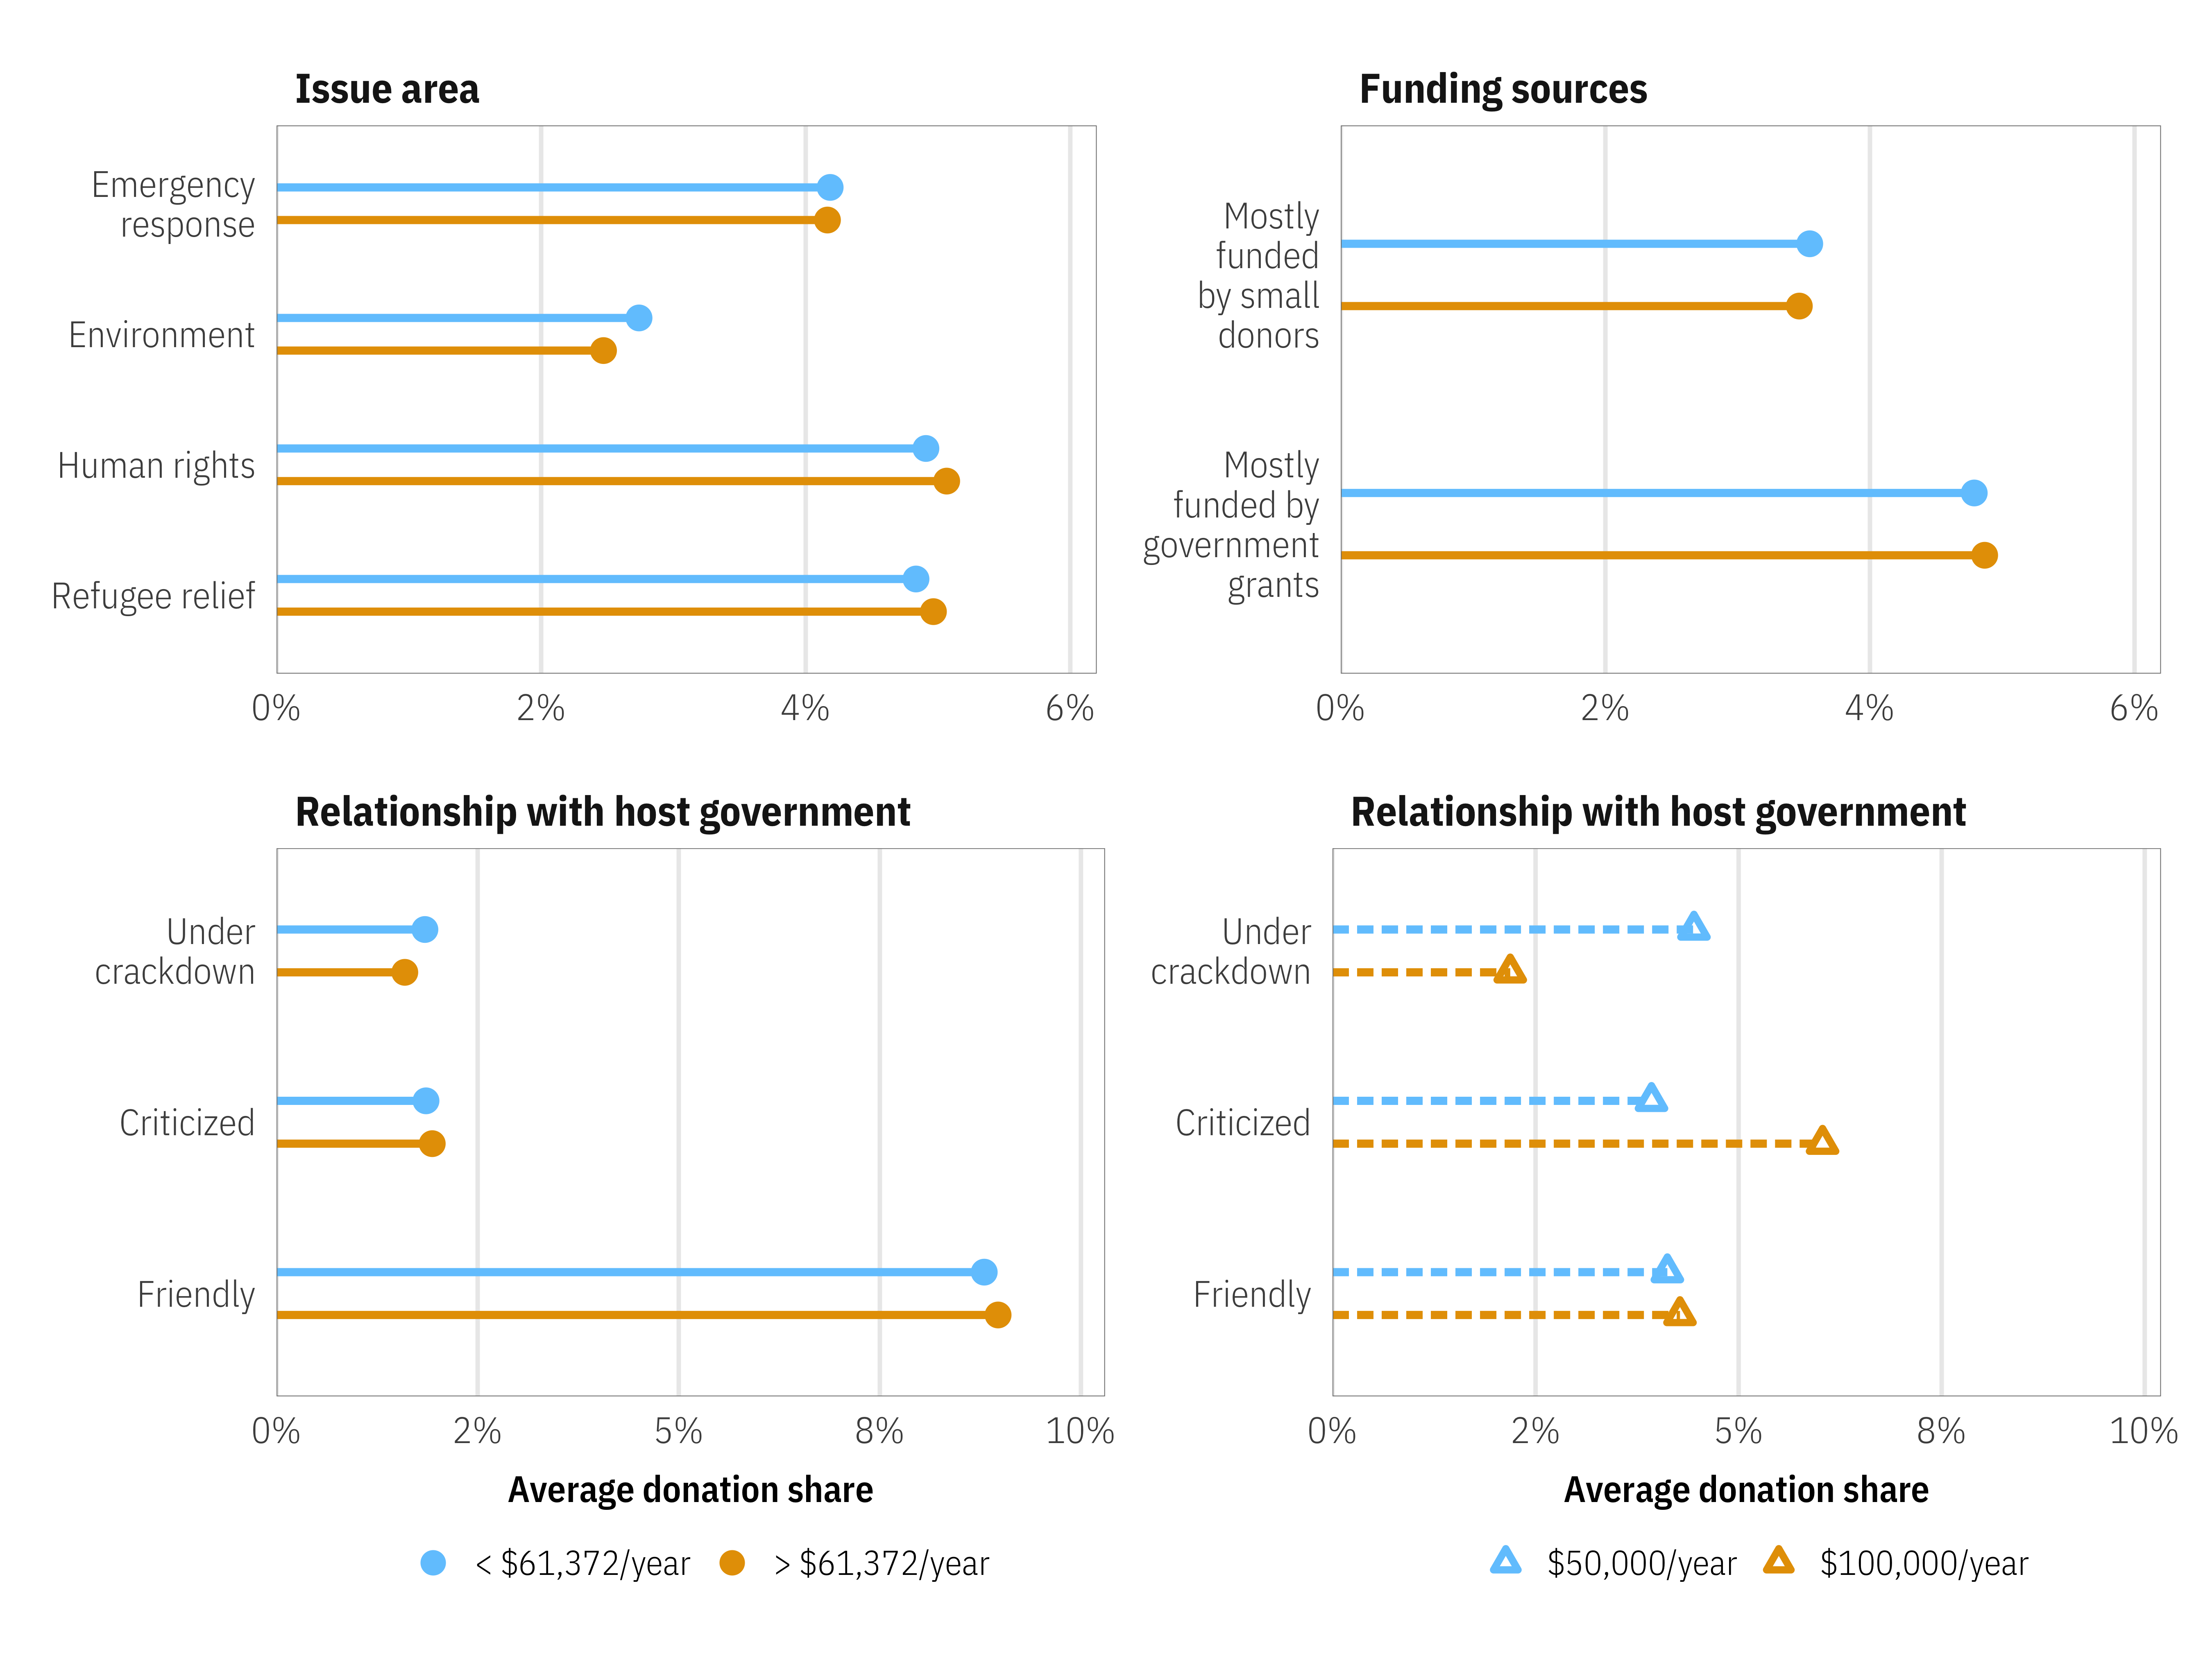
Figure 1: Average predicted donation market shares across all personas, segmented by persona income across organizational issue area, relationship with host government, and funding sources
Regardless of income, personas respond better to human rights and refugee assistance organizations, followed closely by emergency response organizations. Environmental NGOs have the lowest market share across both levels of incomes. There are negligible differences across income levels—wealthier personas show a slight preference towards human rights and refugee organizations. This is possibly because income correlates with interest in public affairs and political activity—individuals who are wealthier arguably have more time and resources to follow the news and be continuously engaged in their communities and in other activist causes. There are no sizable differences in donation preferences by income across different forms of NGO funding—both levels of income tend to prefer organizations funded by government grants over small donors.
An organization’s relationship with its host government does influence market shares across levels of income, but the size of this difference depends on the magnitude of income. In general, personas prefer to donate to organizations with friendly relationships with their host governments and avoid those under crackdown. Wealthier donor personas are more likely to prefer donating to organizations that are criticized by their host governments. This falls in line with their preference for human rights organizations, which have more contentious missions and are more likely to be targeted. This support, however, evaporates as crackdown intensifies. High-income personas are the least likely demographic to prefer donating to NGOs under crackdown. Their lower income counterparts, on the other hand, are generally unfazed by NGOs’ relationships with governments, maintaining the same average market share across all three types of host country relationships. Patterns in preferences for issue area and funding sources remain constant across both methods of categorizing income—crackdown only has an effect on very high-income personas. Income thus appears to influence preferences particularly for NGOs facing crackdown abroad—wealthy donors are perhaps fair-weather friends that are more likely to withdraw their support when an organization’s work becomes more difficult.
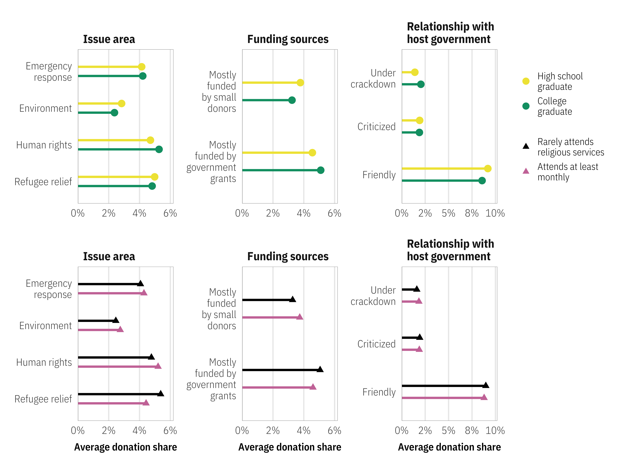
Figure 2: Average predicted donation market shares across all personas, segmented by persona education and religiosity across organizational issue area, relationship with host government, and funding sources
While education and religiosity are both important drivers of individual philanthropy, neither are associated with any sizable differences in persona donation patterns (as seen in Figure 2). Human rights issues attract a slightly larger market share of personas who are college graduates or who attend religious services at least monthly, while refugee issues are more likely to attract less religious personas, but these differences are minor. Preferences are consistent for different sources of funding as well—personas generally prefer organizations funded mostly by government grants. Persona preferences across different organizational relationships with host governments are also consistent across education and religiosity, with most personas preferring to donate to NGOs that enjoy friendly relations abroad.
Next, we examine how differences in public affairs knowledge, experience, and political ideology influence a persona’s propensity to donate to an organization. We vary personas along two dimensions: (1) political ideology, with semi-liberal and semi-conservative political leanings (2 and 5 on a 7-point scale), and (2) knowledge and experience with public affairs and the news, with personas that either follow national and international news and that have traveled abroad or personas that do not follow the news or travel.
We combine these dimensions with an additional set of donor characteristics that vary a persona’s level of social trust. Personas with high levels of trust support political institutions and charities, think people should be more charitable, frequently volunteer, donate to charity once a month, have a history of political activism, and are members of an association. Personas with low levels of trust have the opposite characteristics: they do not trust political institutions or charities, rarely donate or volunteer, and are not members of associations.
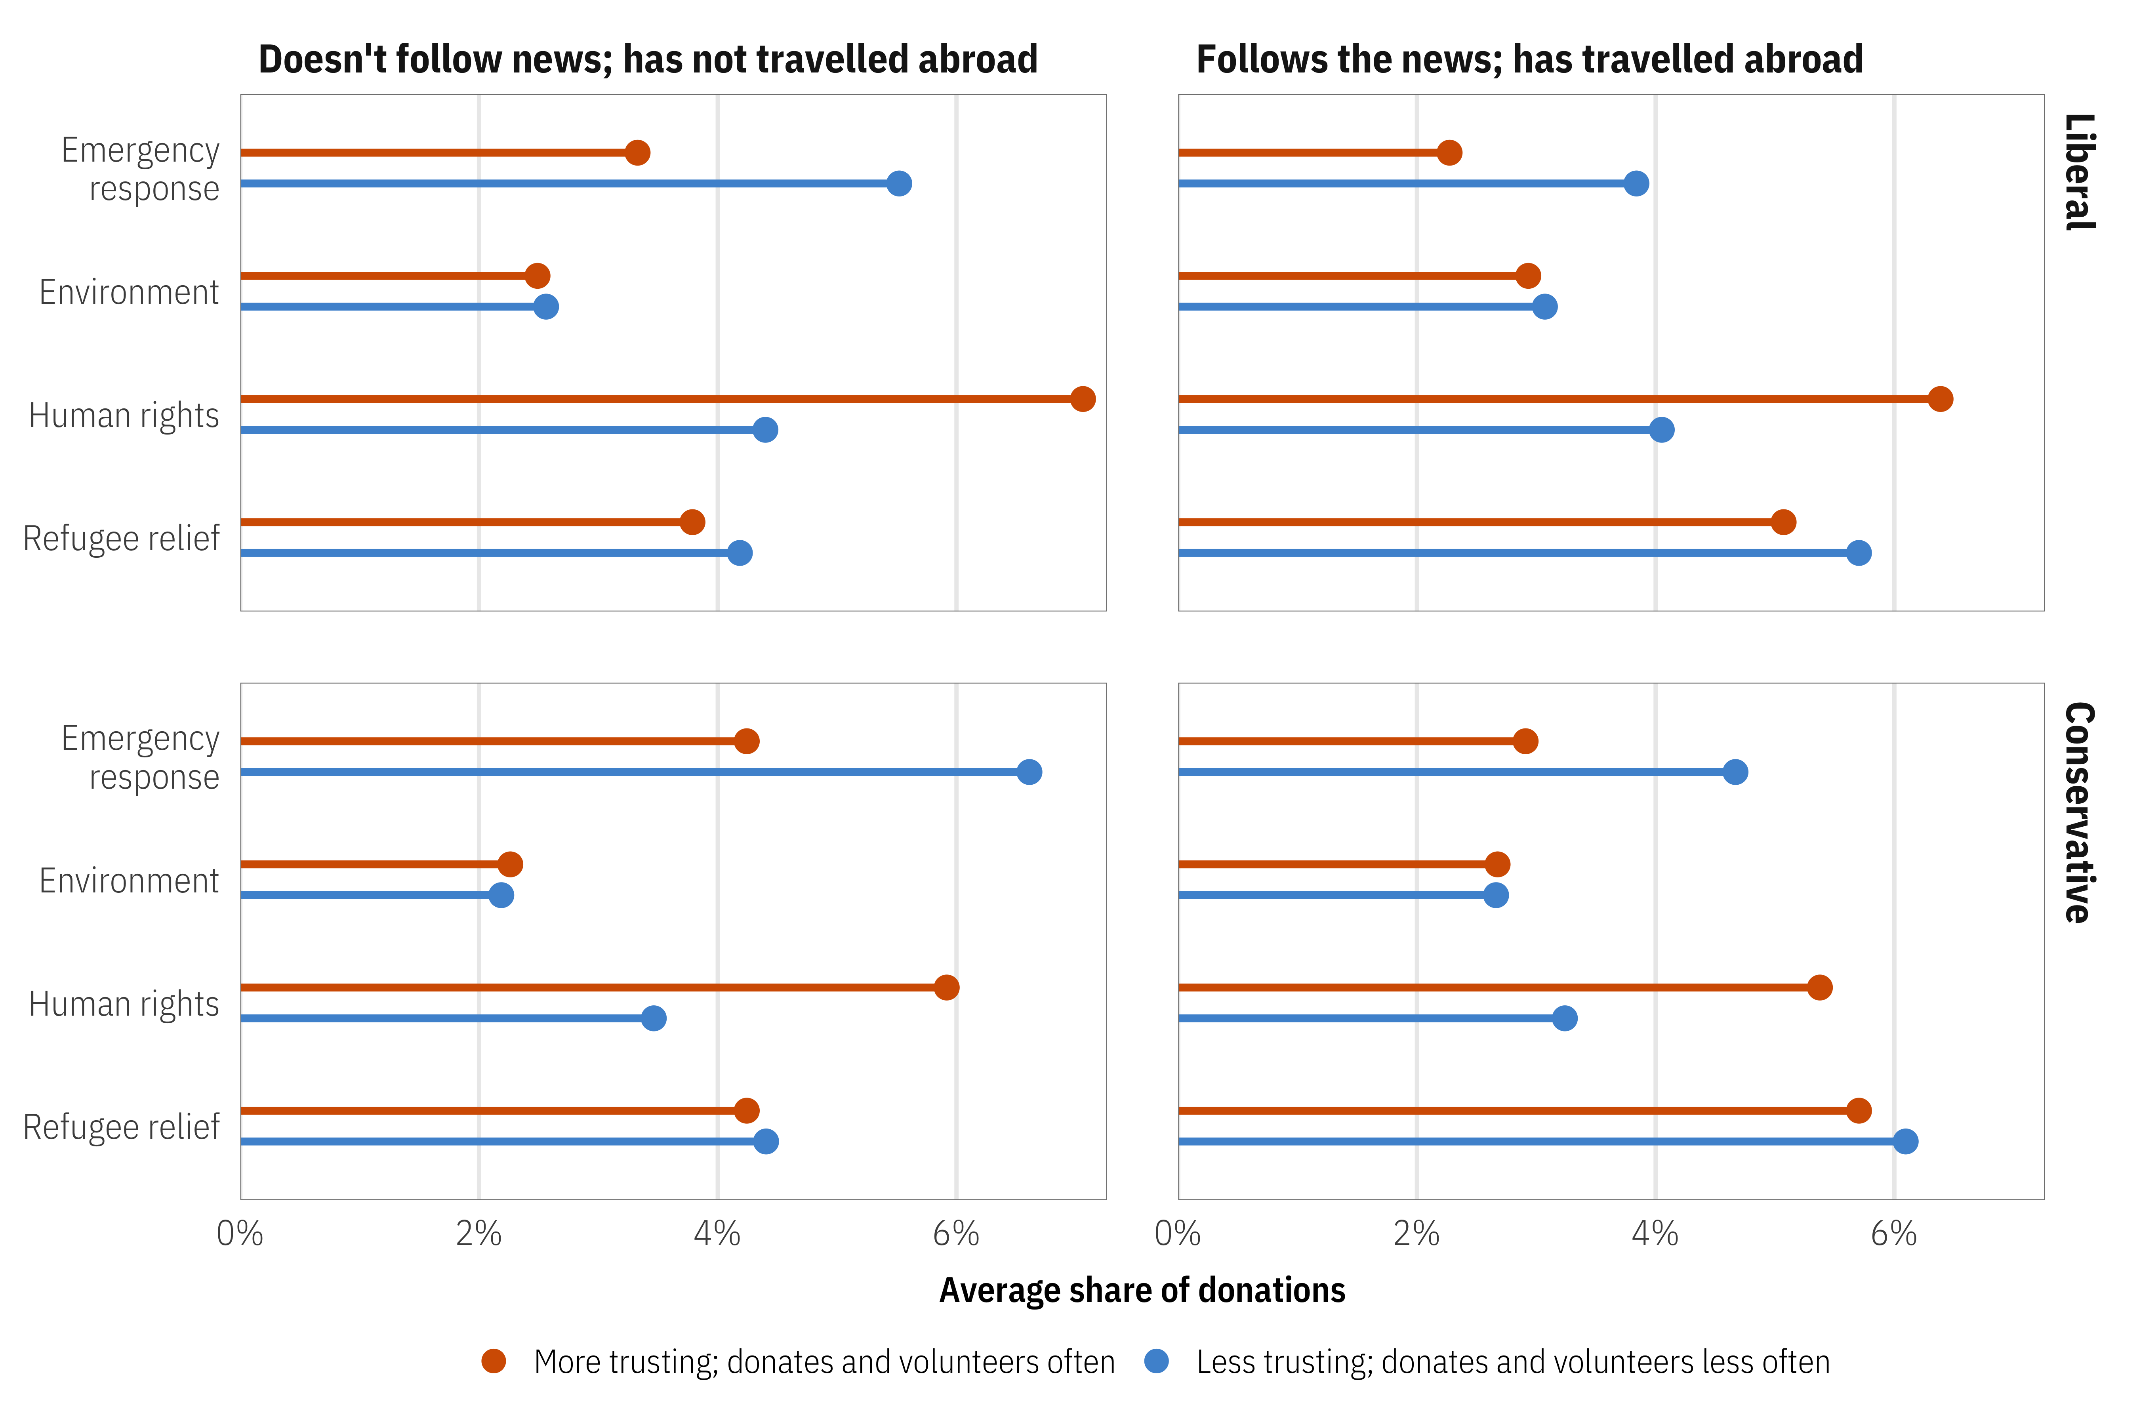
Figure 3: Average predicted donation market shares across all personas, segmented by persona public affairs knowledge, political ideology, and social trust across different NGO issue areas
Figures 3 and 4 show the results of the market simulation across these three dimensions of persona characteristics, varying public affairs knowledge, political ideology, and social trust. Personas respond differently to organizational issue areas. In Figure 3, those who follow the news and travel abroad are more likely to prefer donating to human rights organizations than their less knowledgeable and less traveled counterparts. Personas who do not follow the news or travel show a greater preference for emergency response and refugee relief organizations. There are no strong ideological effects across issue areas. Both conservative and liberal personas tend to follow similar patterns of preference across NGO issue.
Social trust plays a substantial role in determining simulated market share, however. Those who trust social and charitable institutions are very likely to prefer donating to human rights organizations, regardless of their public affairs knowledge or political leanings. In all circumstances, those with high levels of trust have a 7–10% chance of donating to a human rights organization, on average. Personas with low levels of trust, on the other hand, strongly avoid human rights organizations and prefer to donate to refugee and emergency response NGOs. The difference is substantial—a liberal persona with high levels of public affairs knowledge and experience will give to a human rights organization 10% of the time, on average if they have high levels of trust, but less than 3% of the time if they are less trusting. Trust in charities and institutions is a key factor in deciding to donate to more contentious human rights organizations.
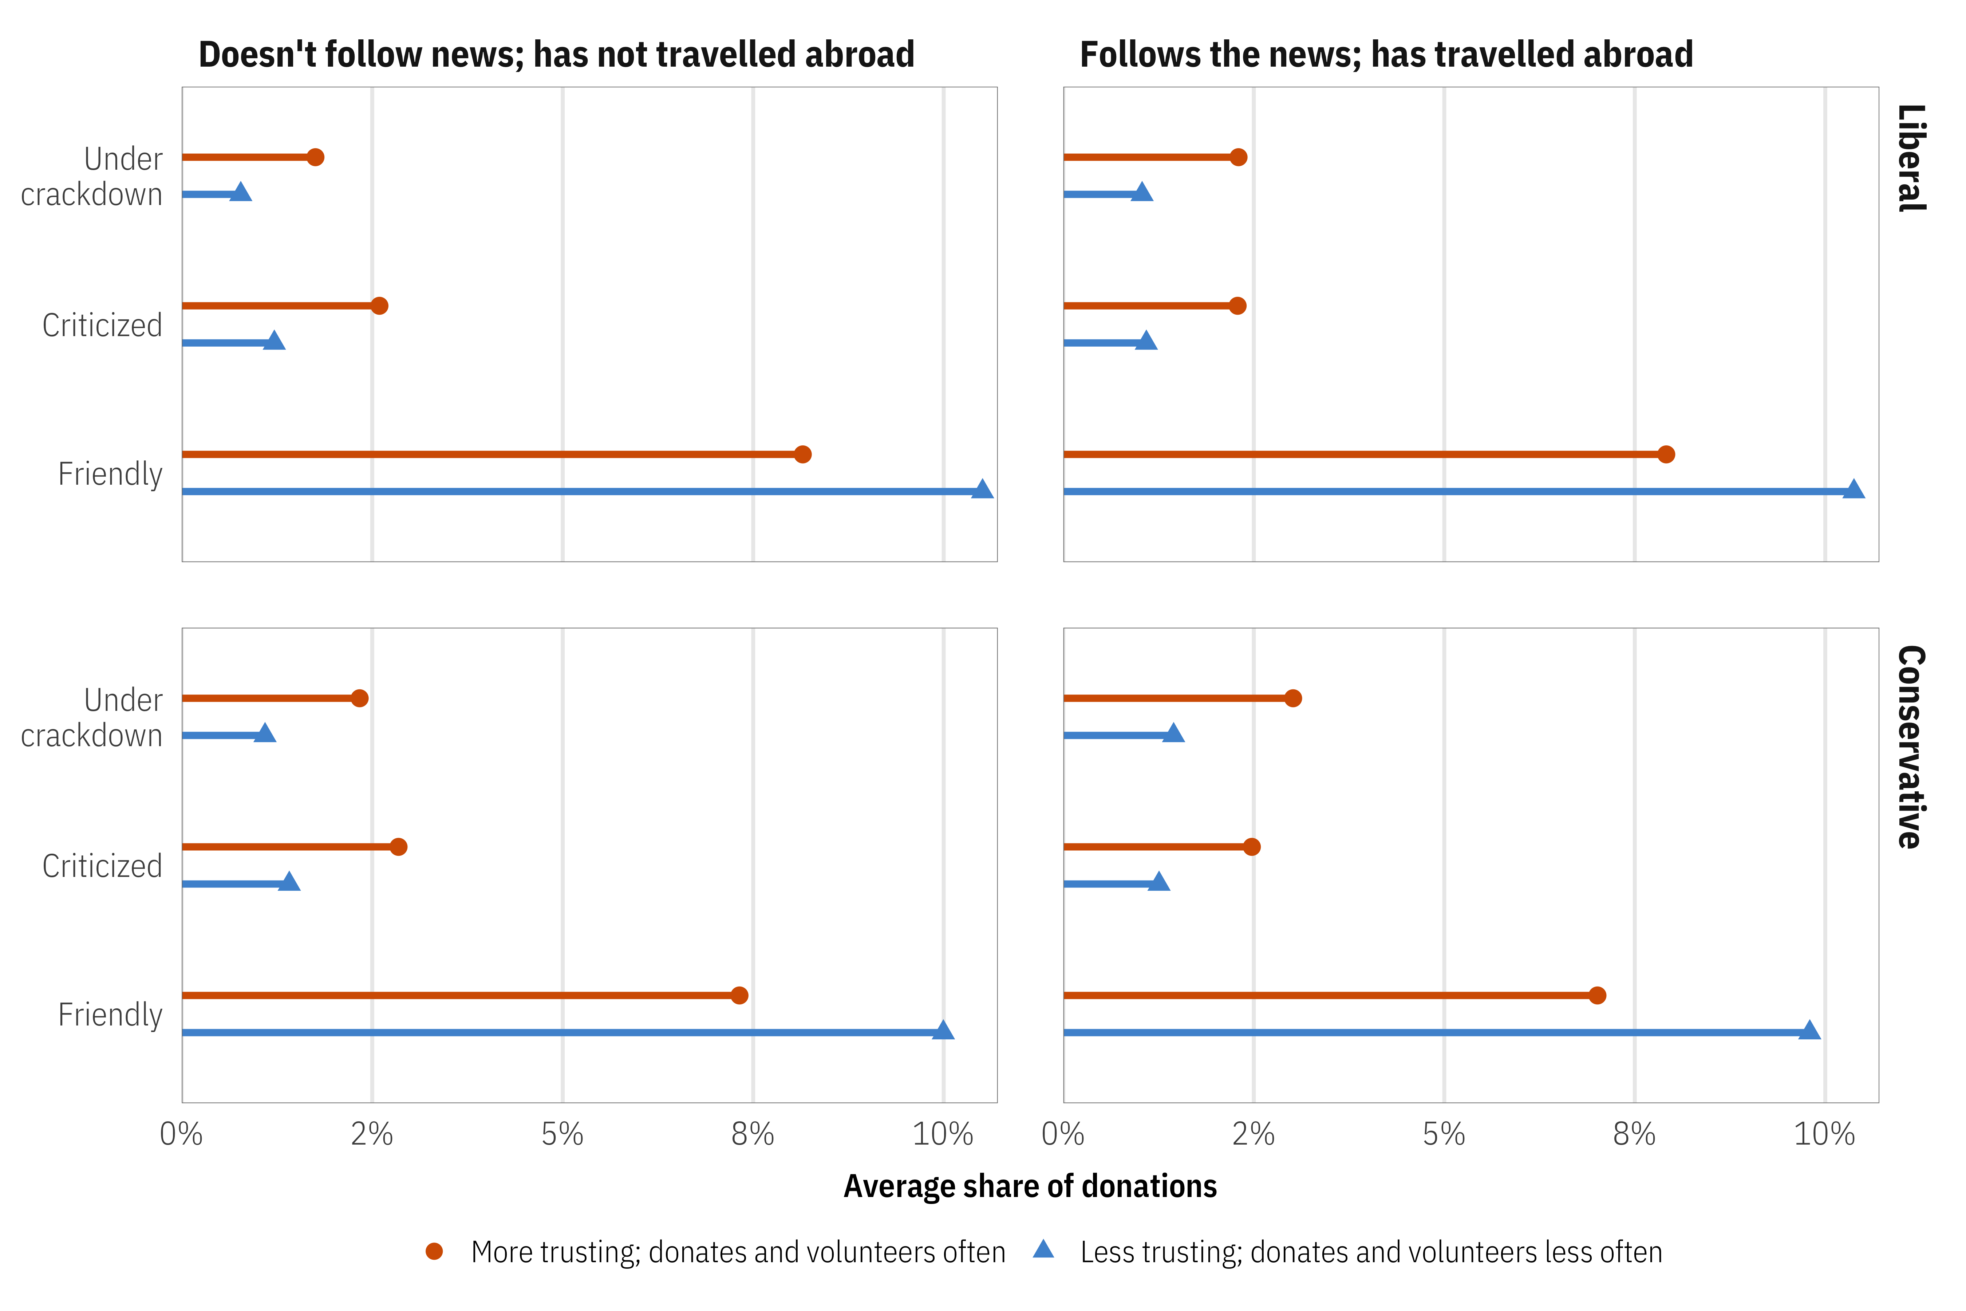
Figure 4: Average predicted donation market shares across all personas, segmented by persona public affairs knowledge, political ideology, and social trust across different NGO–host government relationships
Figure 4 shows how personas respond to different NGO–host government relationships. Public affairs knowledge and experience has little effect on donor preferences, as the average market shares are roughly identical across the two columns of the figure. Persona preferences toward friendly, criticized, and legally suppressed organizations do not change much across different ideological views. The strongest, most overriding factor in determining donor preferences when considering an organization’s relationship with its host country is social trust.
Personas across both levels of social trust are most likely to donate to organizations with friendly relationships with their host governments. However, those with higher trust are less likely to be deterred by poor host-country relationships, while those with low trust tend to not donate to organizations facing criticism or crackdown abroad. A friendly relationship with a host government may be a manifestation of a belief that NGOs act appropriately and exert a positive influence on society. Once an organization faces criticism or crackdown, however, support deteriorates rapidly among personas with low social trust, since such a crackdown could be perceived as a violation of the persona’s trust in the charity—that is, the organization must be doing something wrong to deserve criticism. When the risk of a certain action is higher, people need higher levels of confidence or trust to engage in that action (Coleman, 1990). When NGOs have goals that are harder to accomplish (as is the case under shrinking civic space), there is greater uncertainty that the donated money will meaningfully contribute to the intended cause.
Personas with high levels of trust, on the other hand, continue supporting legally besieged organizations and show targeted groups the benefit of the doubt. Crackdown on NGOs thus sours organizations’ least trusting individual donors. Overall, our results support research that donors with high levels of trust are more active in giving than those with low levels of trust (Sargeant & Hudson, 2008) and that trust especially matters when individuals donate to organizations working under great uncertainty and towards difficult goals (Wiepking, 2010).

Concerns about inference and generalizability
Our conjoint experiment raises two main concerns for inference: (1) prior knowledge and opinions about these organizations could influence respondents’ choices, and (2) the generalizability of these results outside the American context. We explore both below.
All four organizations from the experiment are well-known, and it is likely that participant responses reflect prior beliefs and news coverage about Amnesty, Oxfam, Greenpeace, and the Red Cross. For instance, in February 2018, news broke out about sexual abuse and misconduct at Oxfam and several other prominent organizations, including Amnesty International and Save the Children. This may have potentially strengthened a narrative that the nonprofit sector suffers from governance failures (Phillips, 2019). In a competitive NGO environment (Cooley & Ron, 2002), maintaining positive perceptions is important as donors who perceive these organizations as untrustworthy may simply take their resources elsewhere. As such, it could be argued that respondents may be less likely to donate to Oxfam or Amnesty because of these scandals.
However, we remain doubtful that the above news would impact our U.S. respondents’ beliefs about these four organizations, as evidence about the effect of these scandals is mixed. Using data from Twitter, Scurlock et al. (2020) find that while Oxfam’s reputation suffered for at least six months after the scandal (but has since recovered), other NGOs facing scandals, such as Save the Children, were able to recover more quickly. More broadly, the effect of scandals was mixed—while reputational damage can lead to a decline in donations and grants, organizations can become more resilient and durable after a public relations recovery.
Additionally, we remain skeptical that this scandal affected U.S. donors, given Oxfam is based in the UK, and “media narratives are often not as unsupportive as often assumed” (Banks et al., 2020, p. 703). Moreover, research shows that when donors feel solidarity or an ideological connection with an NGO, they are likely to consider the organization to be trustworthy, despite the lack of full transparency and oversight (Keating & Thrandardottir, 2017). Even watchdog organizations such as Charity Navigator and Better Business Bureau Giving Alliance have been found to not significantly impact individuals’ trust in nonprofit organizations. Rather, trust is more likely fostered through local networks and personal scrutiny (Tremblay-Boire & Prakash, 2017, p. 643).
We also failed to find any systematic evidence that the Oxfam scandal influenced perceptions of the nonprofit sector in the U.S., likely because the story had far less news coverage in the U.S. Many individual donors have a preference to donate locally and they lack sufficient knowledge to make an informed decision about donating internationally. Knowles & Sullivan (2017), conducting a field experiment in New Zealand, found that only a small number of participants in the study stated that not giving internationally was driven by mistrust. Rather, lack of trust towards overseas NGOs often occurs due to donors perceiving INGOs as having low personal relevance (Faulkner et al., 2015). Overall, the literature suggests that for INGO fundraising, lack of awareness is a much larger issue than specific scandals or specific organizational characteristics that might reduce donor trust and confidence.
The sample of U.S. residents with a prior history of charitable giving also raises questions about generalizability and external validity. Public expectations about the role of government and private funding of the nonprofit sectors differ by country. In the U.S., for instance, NGOs often receive substantial funding through government grants, while those in the UK and France, such as Amnesty International and Médecins Sans Frontières, receive minimal government funding (Stroup, 2012). This could imply that donors in the UK and France may have very different preferences when choosing to donate to government or privately-funded organizations. More comparative research is needed to see if our results would also replicate cross-nationally.
There is also notable country-based variation in general patterns of philanthropy. Though charitable giving is highest in the U.S, such donations are overwhelmingly directed at local and religious causes. This pattern does not hold for many European countries. In the UK, international aid is one of the largest targets of giving (26%). Other countries prioritize international philanthropy even more, such as Germany (74%), Belgium (61%), and Switzerland (43%) (Milner, 2017). Thus, if crackdown on INGOs abroad can elicit the effects found in this paper among U.S. respondents, the results provide much reason for optimism for pursuing individual philanthropy towards INGOs in Europe as well. However, more comparative research is required to confirm these trends.

Implications and conclusion
The global crackdown on civil society has adversely impacted the operations of NGOs. It has not just resulted in net losses of income from official sources to INGOs, it has also affected how and where funds are allocated. We show that individual donors can be useful in sustaining the operations of groups working in challenging environments. Individual donors do not use the same performance-based metrics as official donors and use heuristics to simplify their decision-making. The role of trust may be important in understanding donations preferences towards INGOs working in challenging contexts. While trust is a difficult construct to define, the nonprofit literature conceptualizes trust as a key driver of commitment, which can impact both intention to donate as well as actual donation behavior. With repressive environments, a lack of trust could be further fueled by legal trouble with the NGO host government—a dynamic that individuals may not wish to enter with their dollars. How does trust in NGOs influence individuals’ preferences to donate, especially when groups face crackdown?
Using a simulated market for philanthropic donations towards INGOs, based on data from a nationally representative sample of individuals in the United States who regularly donate to charity, we find several important trends. Trust in political institutions and in charitable organizations matters substantially in shaping donor preferences. Personas with high levels of social and charitable trust prefer donating to human rights organizations that have friendly relationships with their host governments, while personas with low trust are drawn more to emergency response and refugee relief organizations. Personas with low social trust tend to be wary of negative host-country relationships and strongly prefer to donate to organizations that are friendly with their host governments, while personas with high social trust are more willing to stick with legally besieged organizations. This implies that donors who are the most trusting could remain supportive when nonprofits face government criticism and crackdown. The global crackdown on NGOs may thus possibly sour NGOs’ least trusting individual donors. Our findings lend support to research showing that individuals who trust NGOs are more likely to continue their monetary support of NGOs in the face of difficulties and under great uncertainty (Dwyer et al., 1987; Wiepking, 2010).
Our results have important implications for NGOs as they navigate a shrinking civic space and consider the use of different frames to tailor their fundraising appeals to individual donors. Our simulation finds that at least for some kinds of personas, NGOs may benefit from publicizing when they are targets of government crackdown, including that information in their fundraising appeals. However, the larger challenge may be addressing the concerns of donors with low levels of trust, as they are the least likely to donate to organizations facing criticism and crackdown abroad. As Tremblay-Boire & Prakash (2017) argue, “trust in the charity sector cannot be assumed: the sector has to demonstrate that the trust it receives is justified” (p. 643).
When considering INGOs working in different issue areas, studies from a range of countries show that levels of giving are lowest for refugee and asylum organizations. Rather, donors giving to international causes tend to support international disaster relief and religious groups (Robson & Hart, 2020). However, some of the former are precisely the organizations facing crackdown. More research is needed to answer how contentious or advocacy organizations can appeal to broader array of potential foreign donors to increase levels of charitable-giving towards them.
To be clear, research on international giving by individuals, especially in the era of closing civic space, is not meant to find answers that can act as substitutes for strategic policy responses, especially by official aid donors and foundations. However, many INGOs are under immediate threat, and individual-level philanthropy can help support these organizations. Existing initiatives such as the Lifeline Embattled CSO Assistance Funds provide models for channeling such funds. In the face of legal crackdowns abroad, individual donations are an important additional funding source for besieged NGOs.

References
Banks, N., Schulpen, L., & Brockington, D. (2020). New sectoral perspectives on international NGOs: Scale, dynamics, and influences. Development in Practice, 30(6), 695–705. https://doi.org/10.1080/09614524.2020.1801595
Bekkers, R. (2003). Trust, accreditation, and philanthropy in the Netherlands. Nonprofit and Voluntary Sector Quarterly, 32(4), 596–615. https://doi.org/10.1177/0899764003258102
Bekkers, R., & Wiepking, P. (2011). A literature review of empirical studies of philanthropy: Eight mechanisms that drive charitable giving. Nonprofit and Voluntary Sector Quarterly, 40(5), 924–973. https://doi.org/10.1177/0899764010380927
Brechenmacher, S. (2017). Civil society under assault: Repression and response in Russia, Egypt, and Ethiopia. Carnegie Endowment for International Peace. http://carnegieendowment.org/2017/05/18/civil-society-under-assault-repression-and-responses-in-russia-egypt-and-ethiopia-pub-69953
Brown, E., & Ferris, J. M. (2007). Social capital and philanthropy: An analysis of the impact of social capital on individual giving and volunteering. Nonprofit and Voluntary Sector Quarterly, 36(1), 85–99. https://doi.org/10.1177/0899764006293178
Bush, S. S. (2015). The taming of democracy assistance: Why democracy promotion does not confront dictators. Cambridge University Press. https://doi.org/10.1017/cbo9781107706934
Carothers, T., & Brechenmacher, S. (2014). Closing space: Democracy and human rights support under fire. Carnegie Endowment for International Peace.
Casale, D., & Baumann, A. (2015). Who gives to international causes? A sociodemographic analysis of US donors. Nonprofit and Voluntary Sector Quarterly, 44(1), 98–122. https://doi.org/10.1177/0899764013507141
Castle, A. L. (2004). Contemporary philanthropy. In D. F. Burlingame (Ed.), Philanthropy in America: A comprehensive historical encyclopedia (Vol. 1, pp. 100–103). ABC-CLIO.
Chaudhry, S., & Heiss, A. (2018). Are funders really responding? Analyzing the impact of global restrictions on NGOs.
Chaudhry, S., & Heiss, A. (2021). Dynamics of international giving: How heuristics shape individual donor preferences. Nonprofit and Voluntary Sector Quarterly. https://doi.org/10.1177/0899764020971045
Chong, D., & Druckman, J. N. (2007). Framing public opinion in competitive democracies. American Political Science Review, 101(4), 637–655. https://doi.org/10.1017/s0003055407070554
CIVICUS. (2017). People power under attack: Findings from the CIVICUS Monitor. http://www.civicus.org/images/People_Power_Under_Attack_Findings_from_the_CIVICUS_Monitor.pdf
Coleman, J. S. (1990). Foundations of social theory. Harvard University Press.
Cooley, A., & Ron, J. (2002). The NGO scramble: Organizational insecurity and the political economy of transnational action. International Security, 27(1, Summer), 5–39. https://doi.org/10.1162/016228802320231217
Coombs, W. T. (2007). Protecting organization reputations during a crisis: The development and application of situational crisis communication theory. Corporate Reputation Review, 10(3), 163–176. https://doi.org/10.1057/palgrave.crr.1550049
Desai, R. M., & Kharas, H. (2018). What motivates private foreign aid? Evidence from internet-based microlending. International Studies Quarterly, 62(3), 505–519. https://doi.org/10.1093/isq/sqy023
Dietrich, S. (2013). Bypass or engage? Explaining donor delivery tactics in foreign aid allocation. International Studies Quarterly, 57(4), 698–712. https://doi.org/10.1111/isqu.12041
Dupuy, K. E., Ron, J., & Prakash, A. (2015). Who survived? Ethiopia’s regulatory crackdown on foreign-funded NGOs. Review of International Political Economy, 22(2), 419–456. https://doi.org/10.1080/09692290.2014.903854
Dupuy, K., & Prakash, A. (2018). Do donors reduce bilateral aid to countries with restrictive NGO laws? A panel study, 1993–2012. Nonprofit and Voluntary Sector Quarterly, 47(1), 89–106. https://doi.org/10.1177/0899764017737384
Dupuy, K., Ron, J., & Prakash, A. (2016). Hands off my regime! Governments’ restrictions on foreign aid to non-governmental organizations in poor and middle-income countries. World Development, 84, 299–311. https://doi.org/10.1016/j.worlddev.2016.02.001
Dwyer, F. R., Schurr, P. H., & Oh, S. (1987). Developing buyer-seller relationships. Journal of Marketing, 51(2), 11–27. https://doi.org/10.2307/1251126
Faulkner, M., Truong, O., & Romaniuk, J. (2015). Barriers to increasing donor support: Evidence on the incidence and nature of brand rejection. Nonprofit and Voluntary Sector Quarterly, 44(5), 1007–1025. https://doi.org/10.1177/0899764014555985
Giving USA. (2019). Giving USA 2019: Americans gave $427.71 billion to charity in 2018 amid complex year for charitable giving. https://givingusa.org/giving-usa-2019-americans-gave-427-71-billion-to-charity-in-2018-amid-complex-year-for-charitable-giving/
Greenhill, R., Prizzon, A., & Rogerson, A. (2013). How are developing countries managing the new aid landscape. ODI Centre for Aid & Public Expenditure.
Havens, J. J., & Schervish, P. G. (2007). Geography and giving: The culture of philanthropy in New England and the nation [Report]. The Boston Foundation.
Hossain, B., & Lamb, L. (2012). The dynamics of environmental giving in Canada: Evidence of rising demand for environmental quality? Economic Papers: A Journal of Applied Economics and Policy, 31(2), 265–273. https://doi.org/10.1111/j.1759-3441.2012.00177.x
Hossain, B., & Lamb, L. (2017). Associational capital and adult charitable giving: A Canadian examination. Nonprofit and Voluntary Sector Quarterly, 46(5), 963–983. https://doi.org/10.1177/0899764017703707
International Center for Not-For-Profit Law. (2021). The civic space initiative. https://www.icnl.org/our-work/global-programs/the-civic-space-initiative
Keating, V. C., & Thrandardottir, E. (2017). NGOs, trust, and the accountability agenda. The British Journal of Politics and International Relations, 19(1), 134–151. https://doi.org/10.1177/1369148116682655
Knowles, S., & Sullivan, T. (2017). Does charity begin at home or overseas? Nonprofit and Voluntary Sector Quarterly, 46(5), 944–962. https://doi.org/10.1177/0899764017703710
Knudsen, E., & Johannesson, M. P. (2019). Beyond the limits of survey experiments: How conjoint designs advance causal inference in political communication research. Political Communication, 36(2), 259–271. https://doi.org/10.1080/10584609.2018.1493009
McGill, L. (2018). Current trends in philanthropy: International giving by U.S. foundations. PND by Candid. https://pndblog.typepad.com/pndblog/2018/11/current-trends-in-philanthropy-international-giving-by-us-foundations.html
Micklewright, J., & Schnepf, S. V. (2009). Who gives for overseas development? Journal of Social Policy, 38(2), 317–341. https://doi.org/10.1017/s0047279408002869
Milner, A. (2017). The state of European philanthropy. Alliance Magazine. https://www.alliancemagazine.org/opinion/state-european-philanthropy/
Needles, C., Wolcheck, D., Sato, G., Ingulfsen, I., McGill, L., Bradford, L., & Ross, N. (2018). The state of global giving by U.S. Foundations, 2011–2015 [Report]. Foundation Center; The Council on Foundations. https://www.issuelab.org/resources/31306/31306.pdf
Phillips, S. D. (2019). Putting Humpty together again: How reputation regluation failes the charitable sector. Nonprofit Policy Forum, 10(4), 1–11. https://doi.org/10.1515/npf-2019-0032
Prakash, A., & Gugerty, M. K. (2010). Trust but verify? Voluntary regulation programs in the nonprofit sector. Regulation & Governance, 4(1), 22–47. https://doi.org/10.1111/j.1748-5991.2009.01067.x
Rajan, S. S., Pink, G. H., & Dow, W. H. (2009). Sociodemographic and personality characteristics of Canadian donors contributing to international charity. Nonprofit and Voluntary Sector Quarterly, 38(3), 413–440. https://doi.org/10.1177/0899764008316056
Robson, A., & Hart, D. J. (2020). Understanding the correlates of donor intention: A comparison of local, national, and international charity destinations. Nonprofit and Voluntary Sector Quarterly, 1–25. https://doi.org/10.1177/0899764020927097
Roth, K. (2016, January 27). The great cicil society choke-out. Foreign Policy. https://foreignpolicy.com/2016/01/27/the-great-civil-society-choke-out-human-rights-democracy-india-russia-china-kenya/
Sargeant, A., & Hudson, J. (2008). Donor retention: An exploratory study of door-to-door recruits. International Journal of Nonprofit and Voluntary Sector Marketing, 13(1), 89–101. https://doi.org/10.1002/nvsm.301
Saxton, G. D., & Wang, L. (2014). The social network effect: The determinants of giving through social media. Nonprofit and Voluntary Sector Quarterly, 43(5), 850–868. https://doi.org/10.1177/0899764013485159
Scurlock, R., Dolsak, N., & Prakash, A. (2020). Recovering from scandals: Twitter coverage of Oxfam and Save the Children scandals. Voluntas: International Journal of Voluntary and Nonprofit Organizations, 31, 94–110. https://doi.org/10.1007/s11266-019-00148-x
Stroup, S. S. (2012). Borders among activists: International NGOs in the United States, Britain, and France. Cornell University Press. https://doi.org/10.7591/9780801464256
Szper, R., & Prakash, A. (2011). Charity watchdogs and the limits of information-based regulation. Voluntas: International Journal of Voluntary and Nonprofit Organizations, 22(1), 112–141. https://doi.org/10.1007/s11266-010-9156-2
Tarrow, S. (2001). Transnational politics: Contention and institutions in international politics. Annual Review of Political Science, 4, 1–20.
Tremblay-Boire, J., & Prakash, A. (2017). Will you trust me?: How individual American donors respond to informational signals regarding local and global humanitarian charities. Voluntas: International Journal of Voluntary and Nonprofit Organizations, 28(2), 621–647. https://doi.org/10.1007/s11266-016-9782-4
US Trust. (2014). High net worth philanthropy. US Trust; the Lilly Family School of Philanthropy.
Wiepking, P. (2010). Democrats support international relief and the upper class donates to art? How opportunity, incentives and confidence affect donations to different types of charitable organizations. Social Science Research, 39(6), 1073–1087. https://doi.org/10.1016/j.ssresearch.2010.06.005
Wiepking, P., & Bekkers, R. (2010). Does who decides really matter? Causes and consequences of personal financial management in the case of larger and structural charitable donations. Voluntas: International Journal of Voluntary and Nonprofit Organizations, 21(2), 240–263. https://doi.org/10.1007/s11266-010-9124-x
Wiepking, P., & Maas, I. (2009). Resources that make you generous: Effects of social and human resources on charitable giving. Social Forces, 87(4), 1973–1995. https://doi.org/10.1353/sof.0.0191
Youde, J. (2019). The role of philanthropy in international relations. Review of International Studies, 45(1), 39–56. https://doi.org/10.1017/s0260210518000220

Broadly speaking, NGOs are any local, national, or international not-for-profit, voluntary organization. They can be domestic (i.e. an NGO that operates entirely in a single state), or international (INGOs). INGOs are composed of members from two or more countries and are organized to advance their members’ international goals and provide services to citizens of other states through transactions with states, private actors, and international institutions (Tarrow, 2001, p. 12).
We use “philanthropy” to connote voluntary giving to promote the common good. We focus on private individual giving rather than foundation or corporate giving. Some perspectives see philanthropy as a strategic long-term practice addressing the root causes of social issues, and charity as a short-term practice focused on providing immediate relief. But many scholars see philanthropy as essentially synonymous with charitable donations, as short-term giving can also address longer-term or strategic issues (Castle, 2004). We use the terms interchangeably since individuals could be giving to legally besieged nonprofits for either purpose.
Giving USA defines the sector of international affairs to include any nonprofit organization working in international development, international relief services, disaster relief, international human rights, international peace and security, foreign policy research and analysis, and international exchange programs.
For exceptions, see Micklewright & Schnepf (2009) on the UK; Rajan et al. (2009) on Canada; Wiepking & Bekkers (2010) on the Netherlands; Casale & Baumann (2015) on the U.S.
See the appendix for the full text of the survey.
A sample size of at least 500 respondents is typical when using conjoint data in a hierarchical Bayesian model. We doubled this amount because we are interested in analyzing subpopulations of respondents, which requires a larger sample.
Specifically, $$ \begin{aligned} \beta &\sim \operatorname{Multivariate} \mathcal{N}(Z \Gamma, \xi) \\ y &\sim \operatorname{Multinomial\ logit}(X \beta, \varepsilon) \end{aligned} $$ where $y$ = which alternative the respondent chooses to donate to, $X$ = design matrix of attribute levels (organizations, issue areas, organizational practices, funding sources, and government relations), $β$ = latent individual preferences for the attribute levels, $Z$ = matrix of individual-level covariates (demographics, political knowledge, attitudes towards charity, etc.), $Γ$ = matrix of coefficients mapping individual-level covariates onto the latent individual-level preferences, and $ε$ and $ξ$ = errors. See the appendix for more details.

